Nima Amir Dastmalchi (505320372)

CS 118

Homework #1

**Problem 1**

Part A: Intuitively, the infinite sum of (absolute value of) the coefficients must be proportional to the area under the curve of one period of the (absolute value of) square wave (which is finite), so the sum must converge, and the coefficients must decrease.

More formally, the integral of $\sin\left(2πnx\right)$ is proportional to $\frac{-1}{n}\cos\left(2πnx\right)$. So, as n increases, the scaling factor decreases.

Part B1:

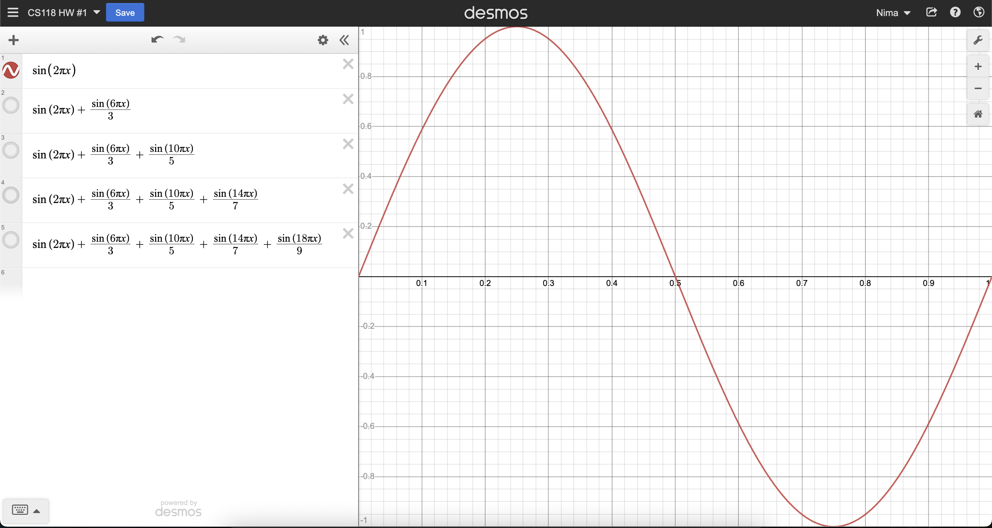 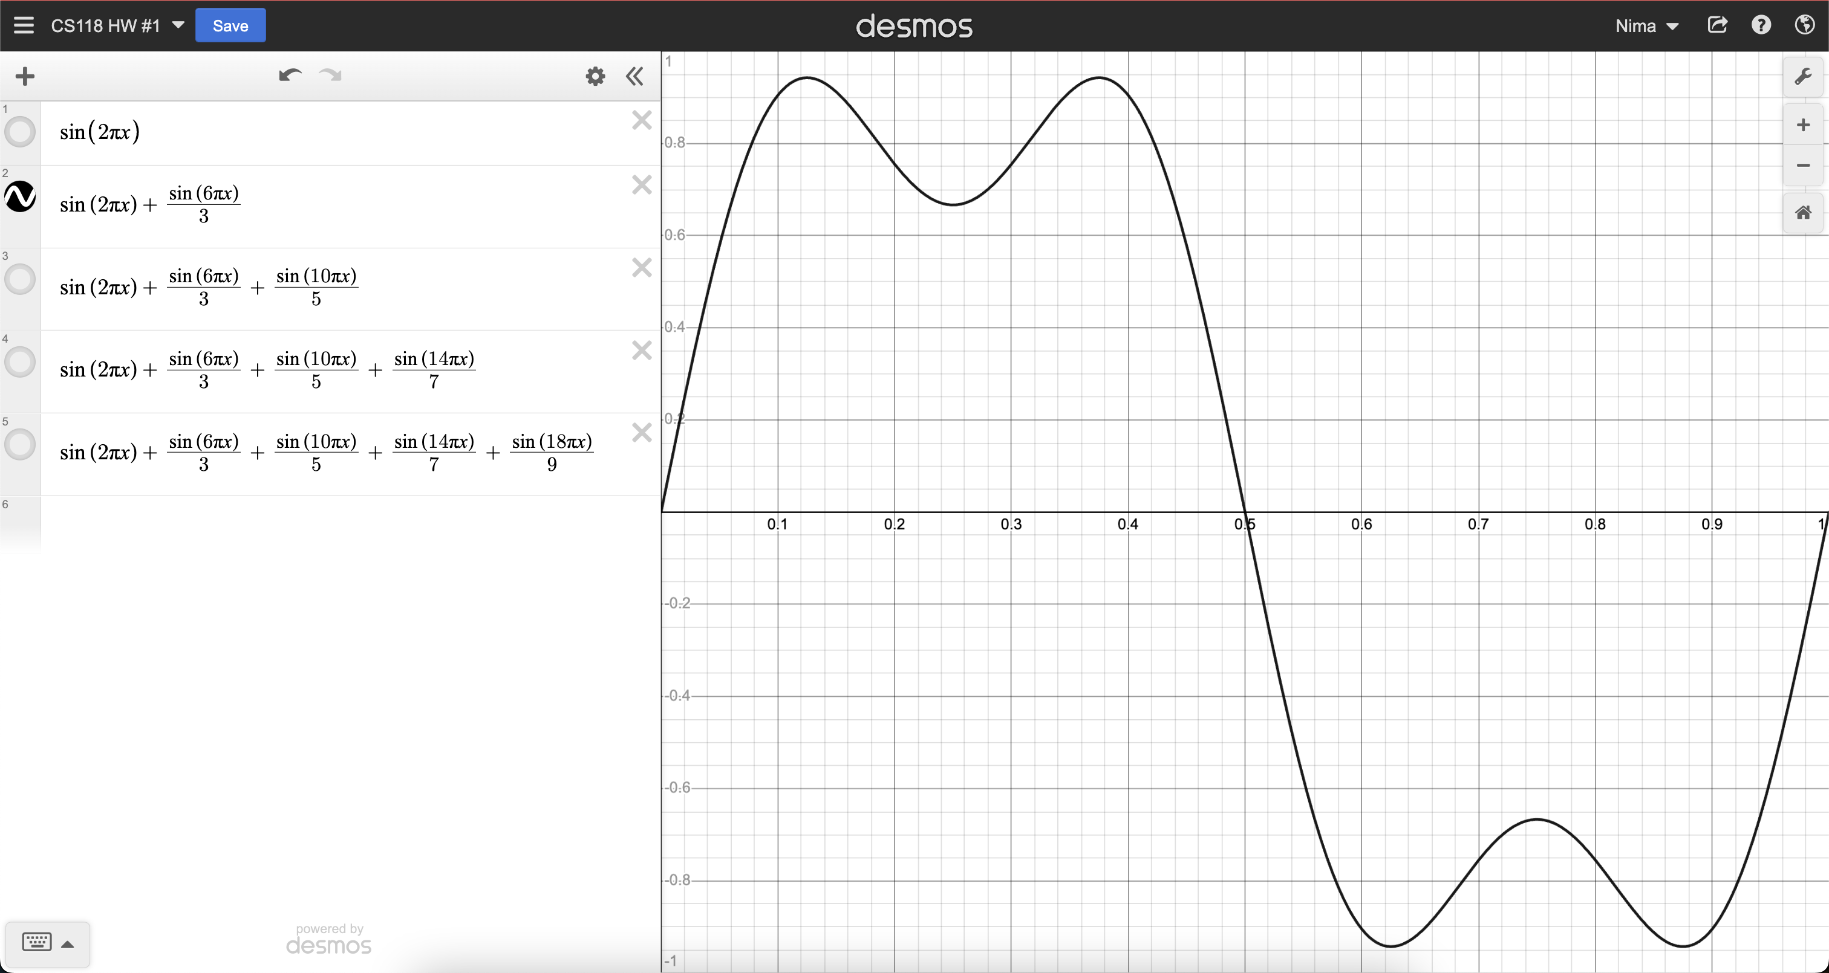

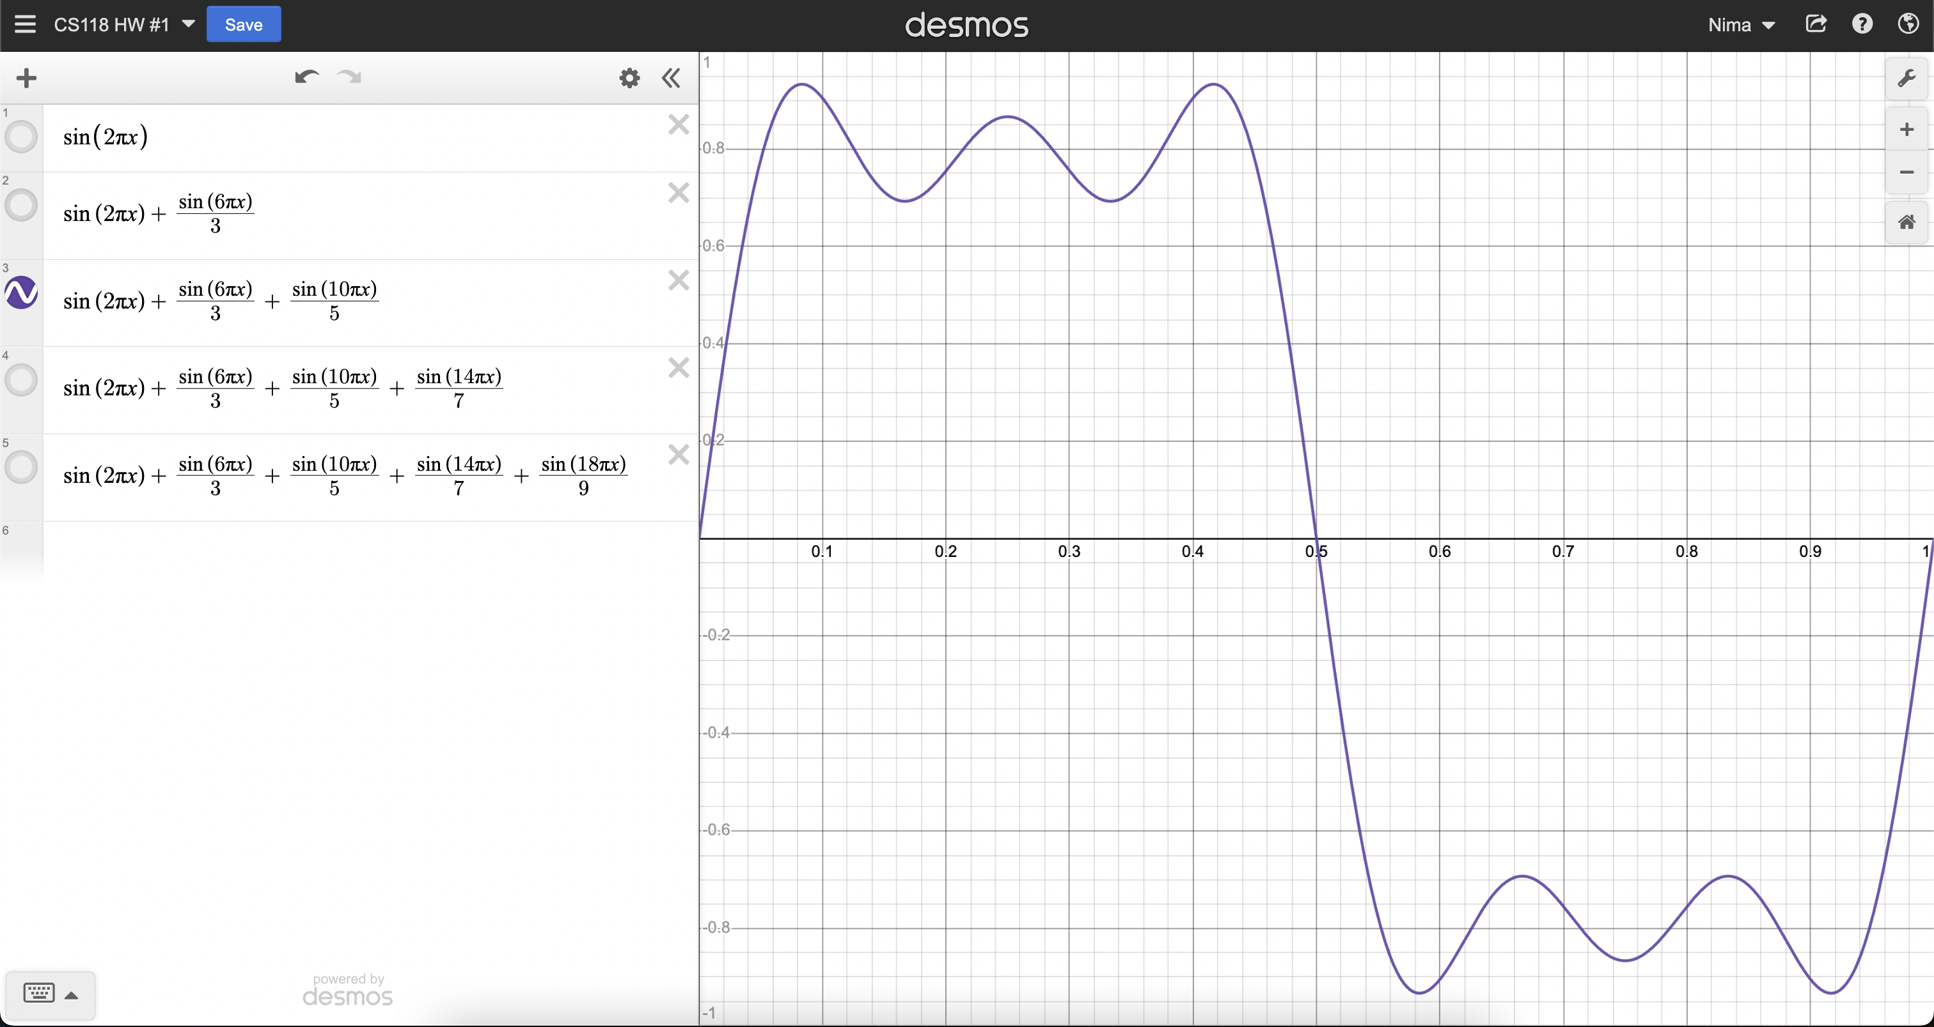 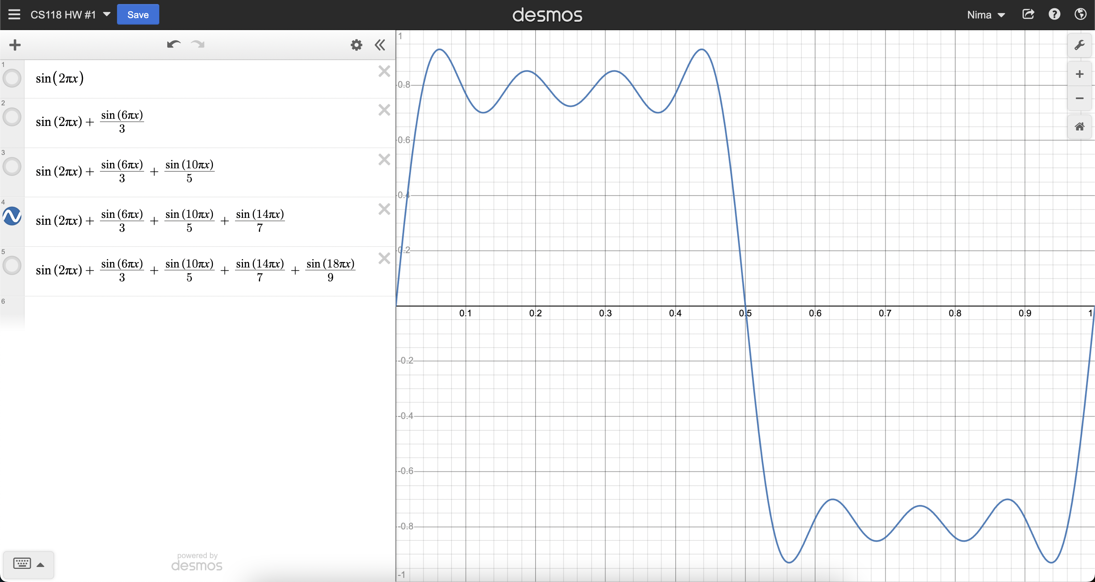

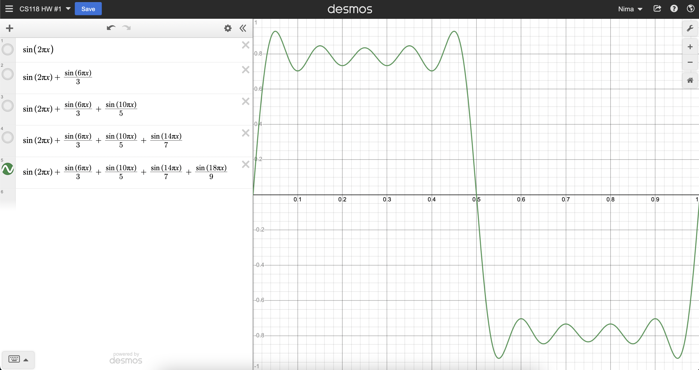

All five waves together:

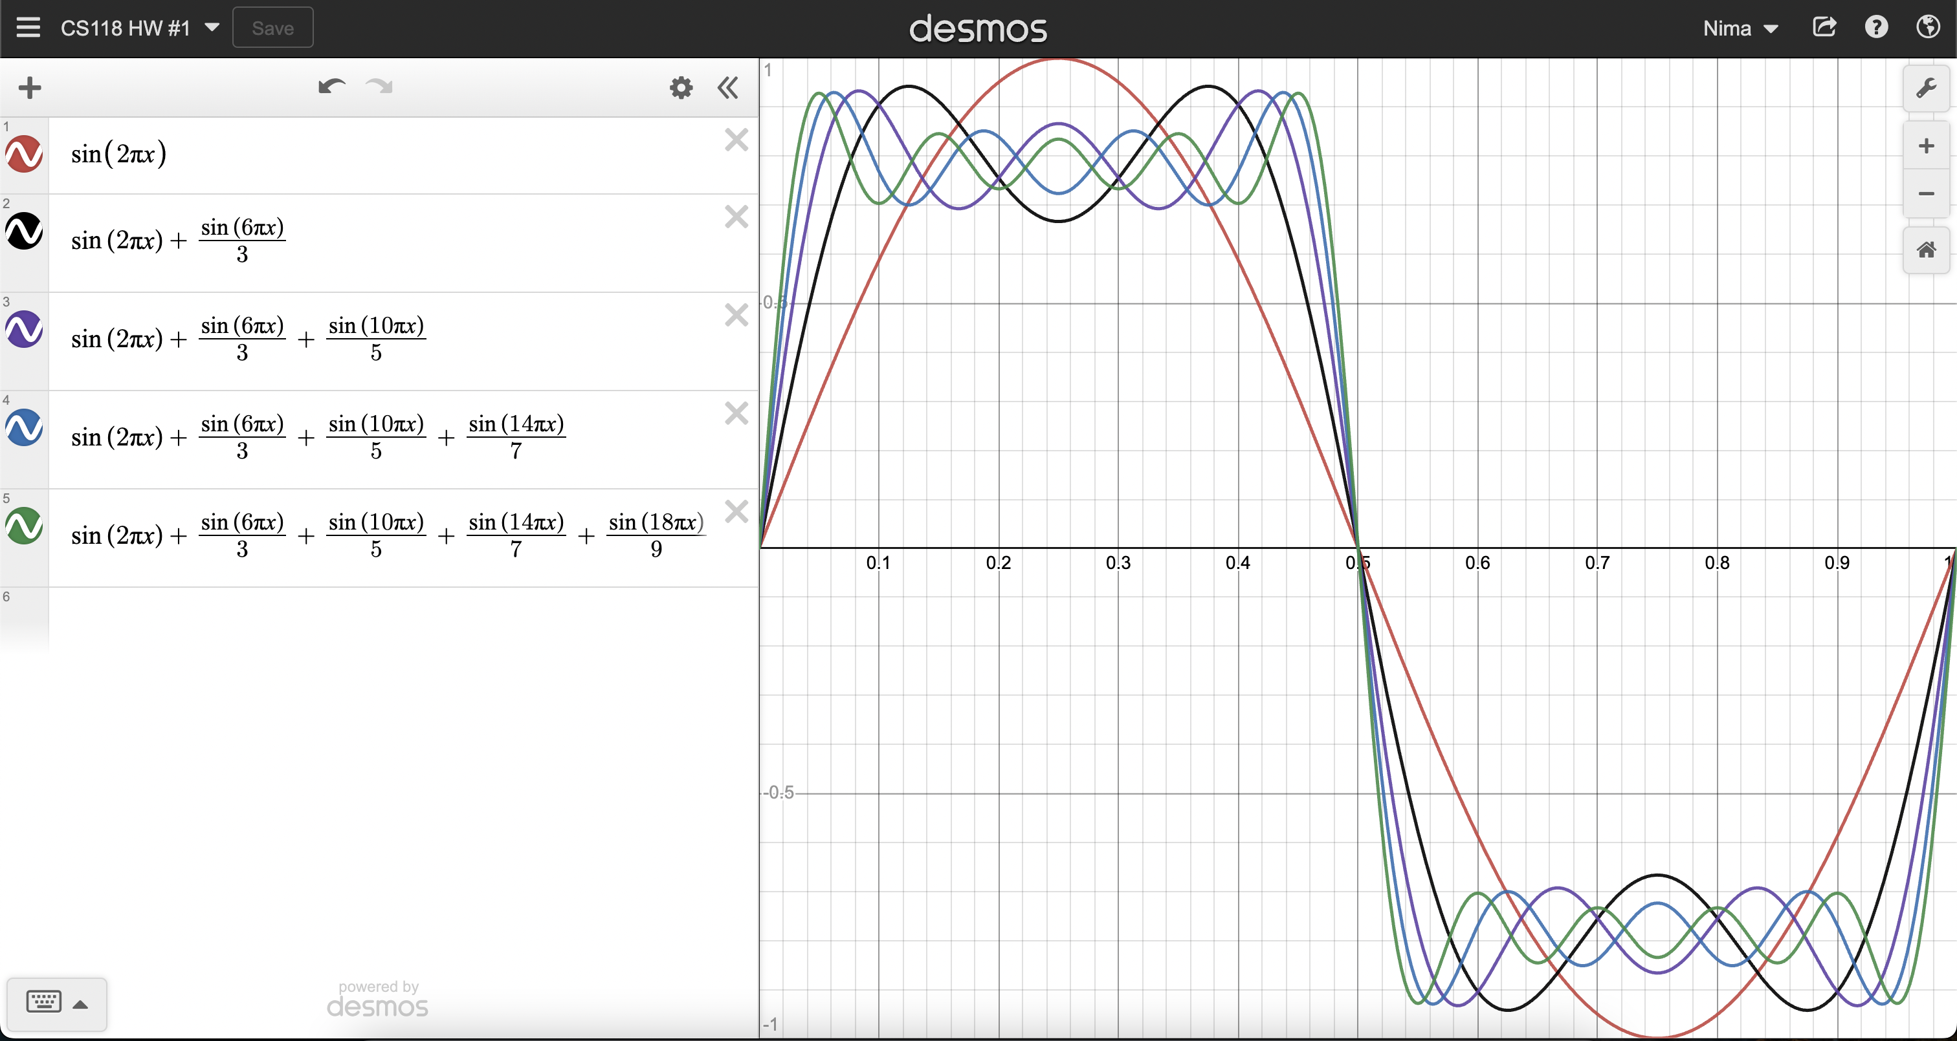

Link to Desmos: <https://www.desmos.com/calculator/xkfwju7rxs>

Part B2:

Note that $f_{min}=0 Hz$ for all 5 approximations.

For approximation 1 (n = 1), $f_{max}=1 Hz$, so the bandwidth is $1 Hz$.

For approximation 2 (n = 2), $f_{max}=3 Hz$, so the bandwidth is $3 Hz$.

For approximation 3 (n = 3), $f_{max}=5 Hz$, so the bandwidth is $5 Hz$.

For approximation 4 (n = 4), $f_{max}=7 Hz$, so the bandwidth is $7 Hz$.

For approximation 5 (n = 5), $f_{max}=9 Hz$, so the bandwidth is $9 Hz$.

Part B3:

Let $v_{A}$ be the actual value, $v_{E}=1$ be the expected value, and $δ$ be the percent error.

For n = 1, the lowest value between 0.1s and 0.4s is 0.7484V:

$$δ=\left|\frac{v_{A}-v_{E}}{v_{E}}\right|*100\%=\left|\frac{0.7484-1}{1}\right|*100\%=25.16\%$$

For n = 2, the lowest value between 0.1s and 0.4s is 0.8488V:

$$δ=\left|\frac{v_{A}-v_{E}}{v_{E}}\right|*100\%=\left|\frac{0.8488-1}{1}\right|*100\%=15.12\%$$

For n = 3, the lowest value between 0.1s and 0.4s is 0.8821V:

$$δ=\left|\frac{v_{A}-v_{E}}{v_{E}}\right|*100\%=\left|\frac{0.8821-1}{1}\right|*100\%=11.79\%$$

For n = 4, the lowest value between 0.1s and 0.4s is 0.8917V:

$$δ=\left|\frac{v_{A}-v_{E}}{v_{E}}\right|*100\%=\left|\frac{0.8917-1}{1}\right|*100\%=10.83\%$$

For n = 5, the lowest value between 0.1s and 0.4s is 0.8959V:

$$δ=\left|\frac{v_{A}-v_{E}}{v_{E}}\right|*100\%=\left|\frac{0.8959-1}{1}\right|*100\%=10.41\%$$

We see that percent error decreases with better approximations.

Pictures:

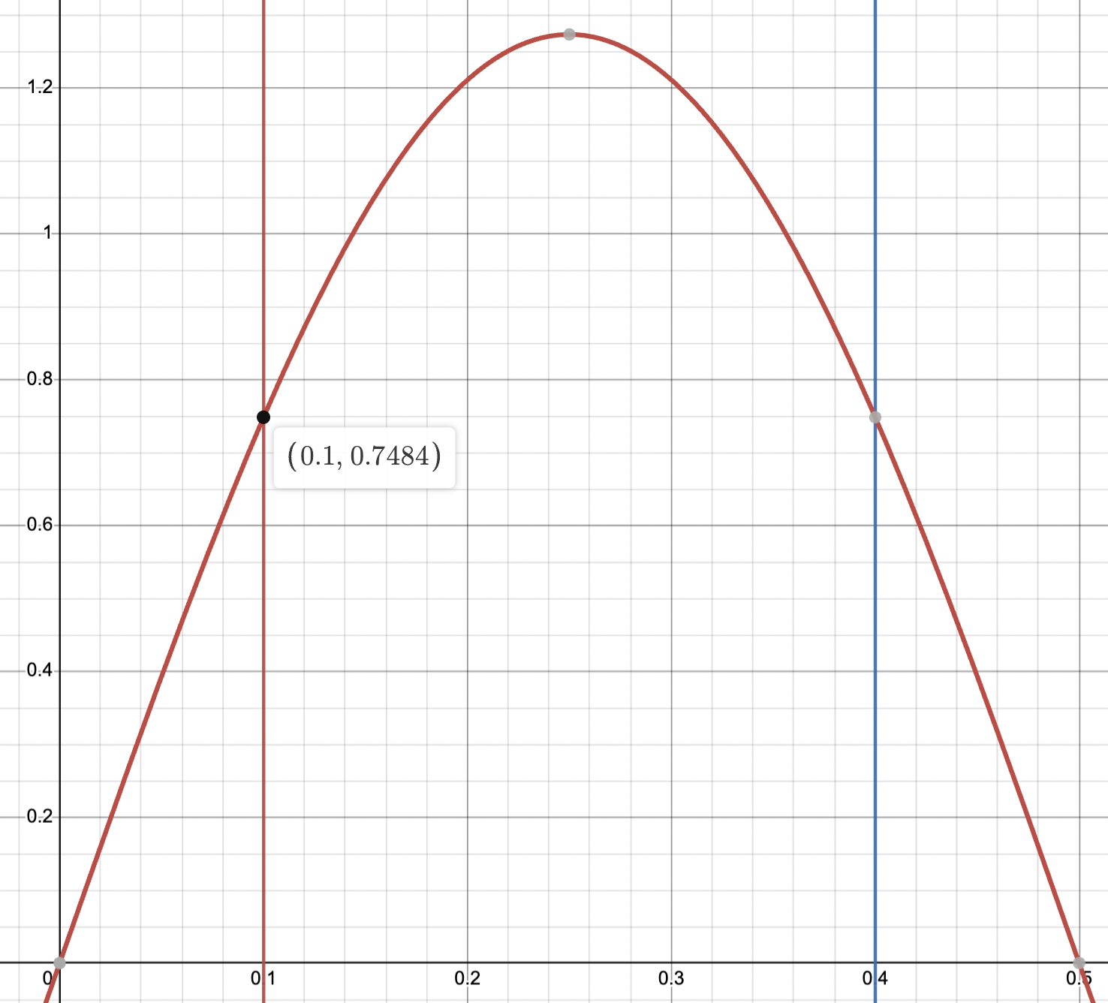 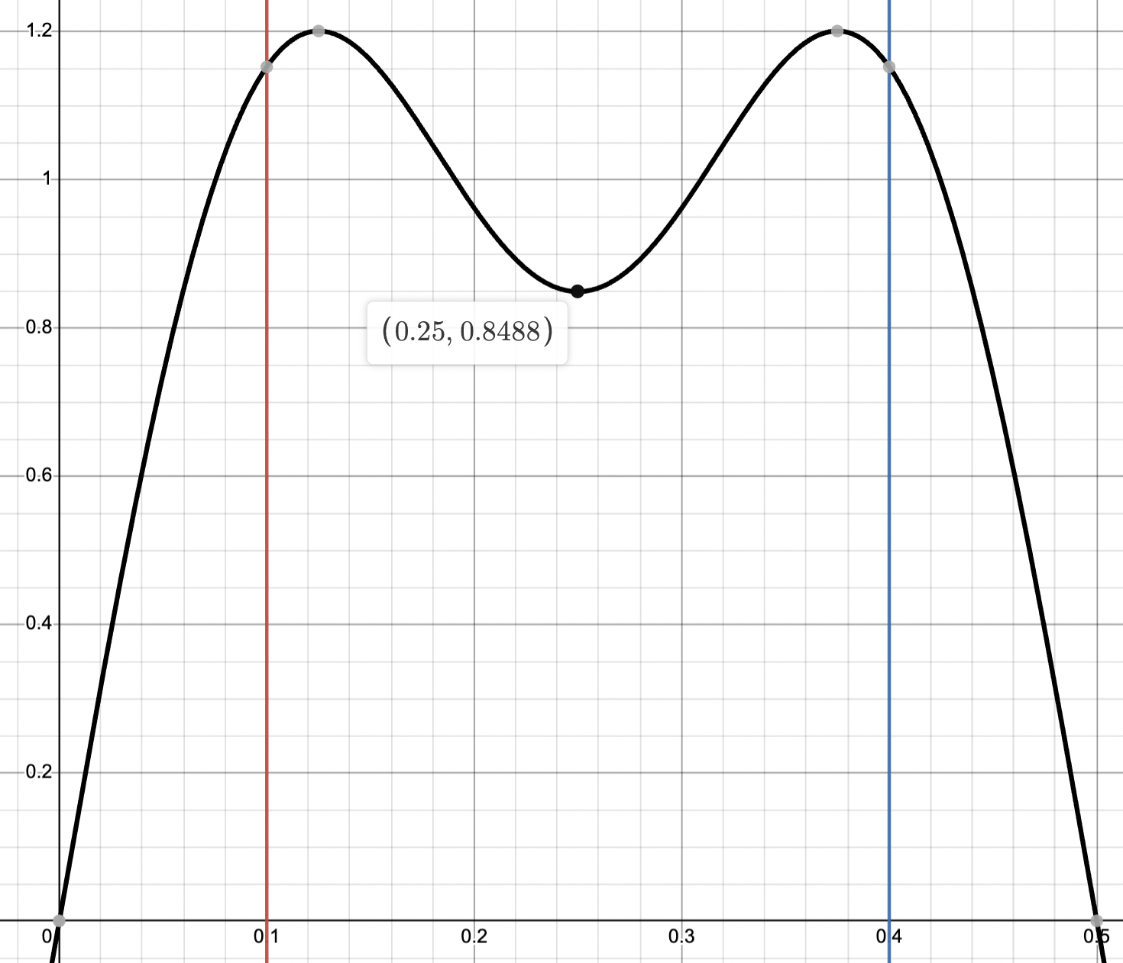 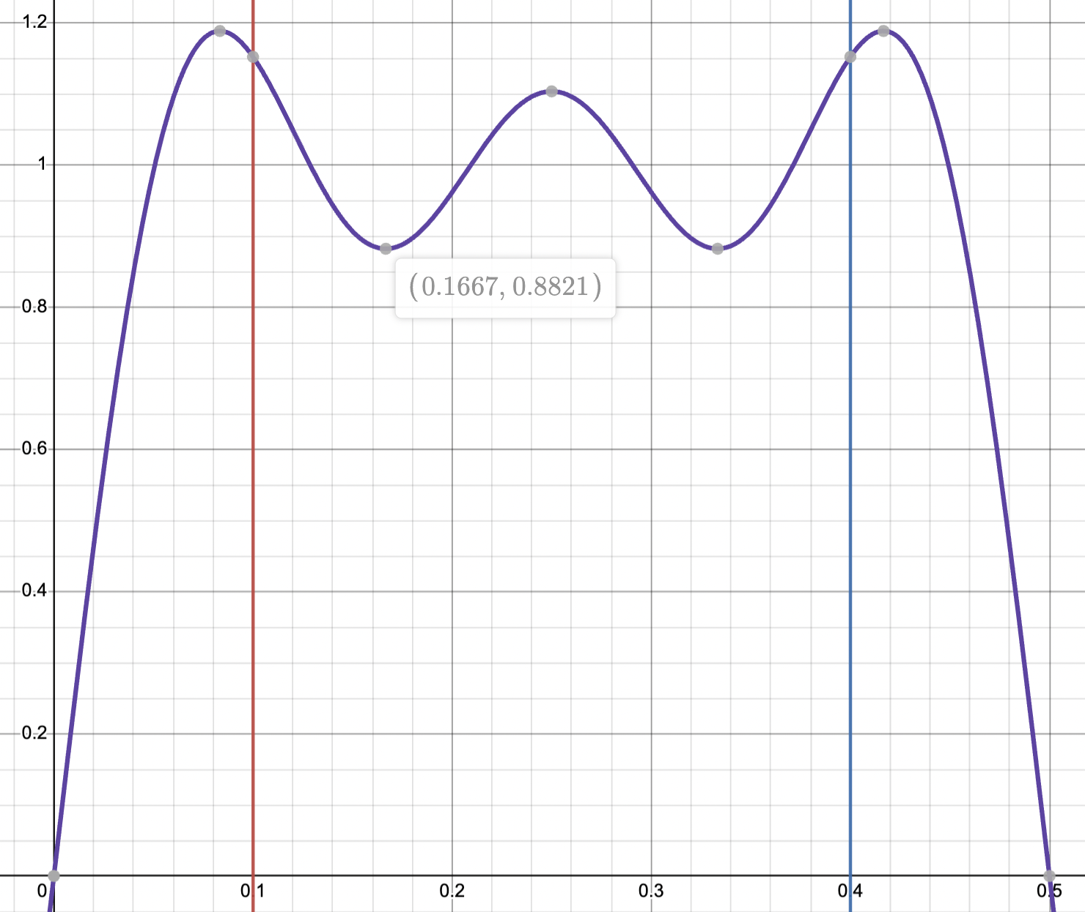

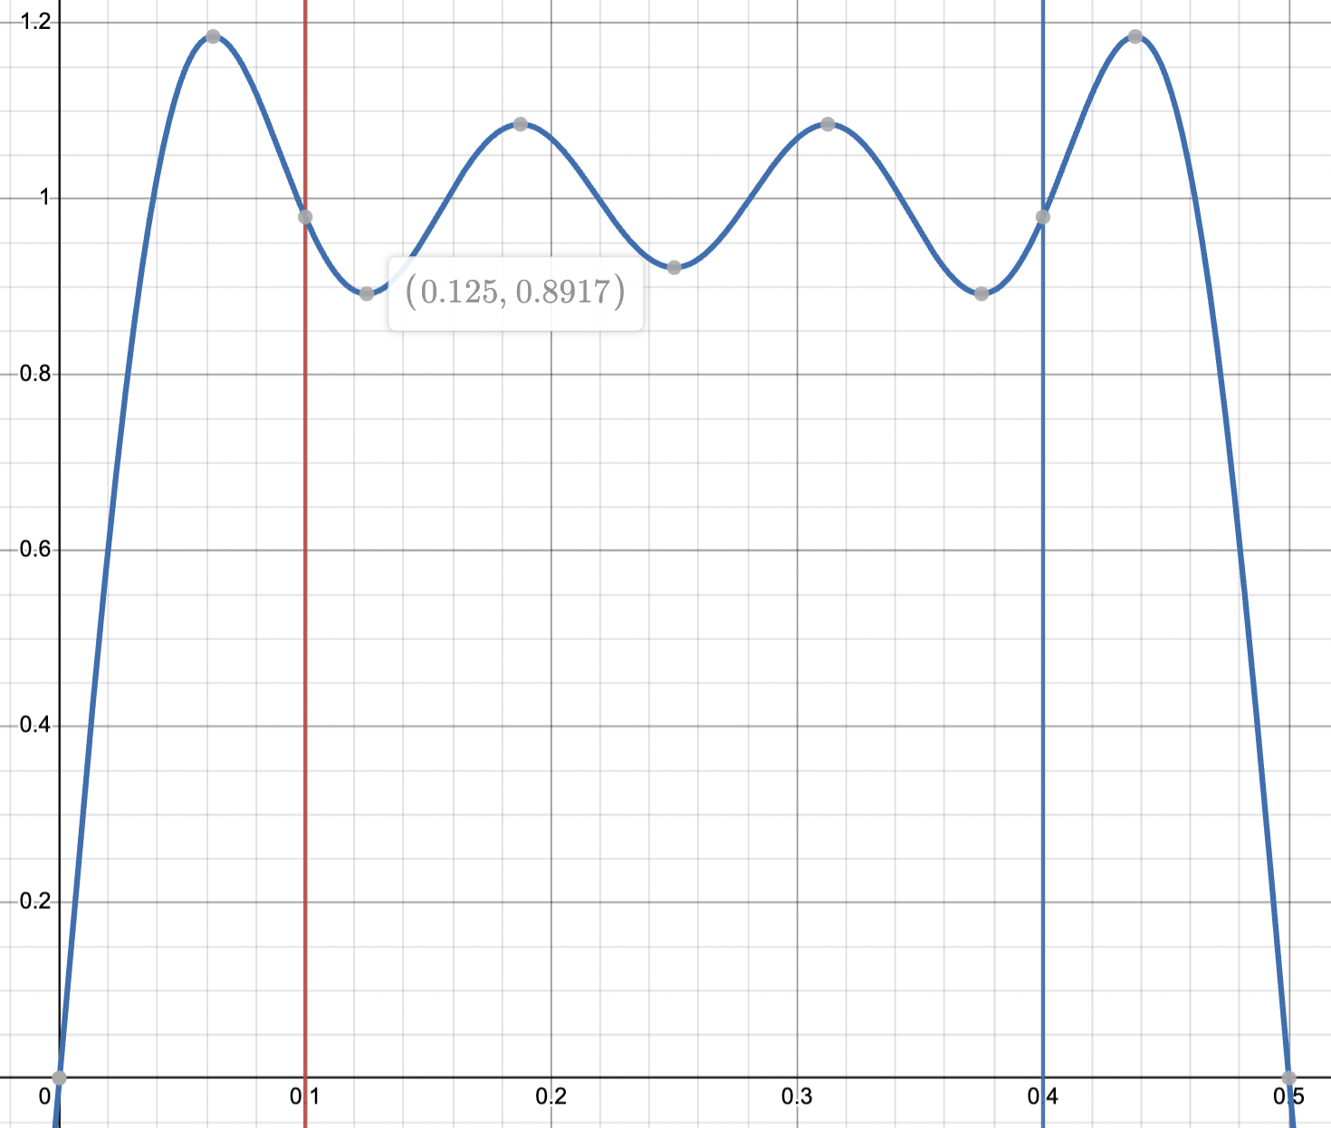 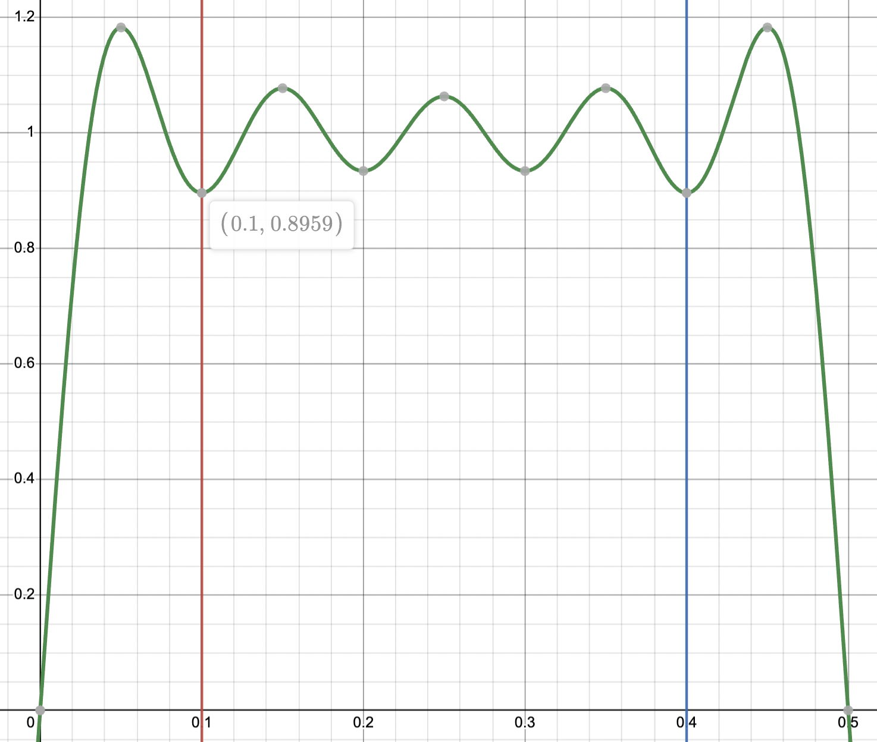

Part B4:

For n = 1, the wave reaches 0.9V at t = 0.1782.

For n = 2, the wave reaches 0.9V at t = 0.0985.

For n = 3, the wave reaches 0.9V at t = 0.0674.

For n = 4, the wave reaches 0.9V at t = 0.051.

For n = 5, the wave reaches 0.9V at t = 0.041.

Pictures:

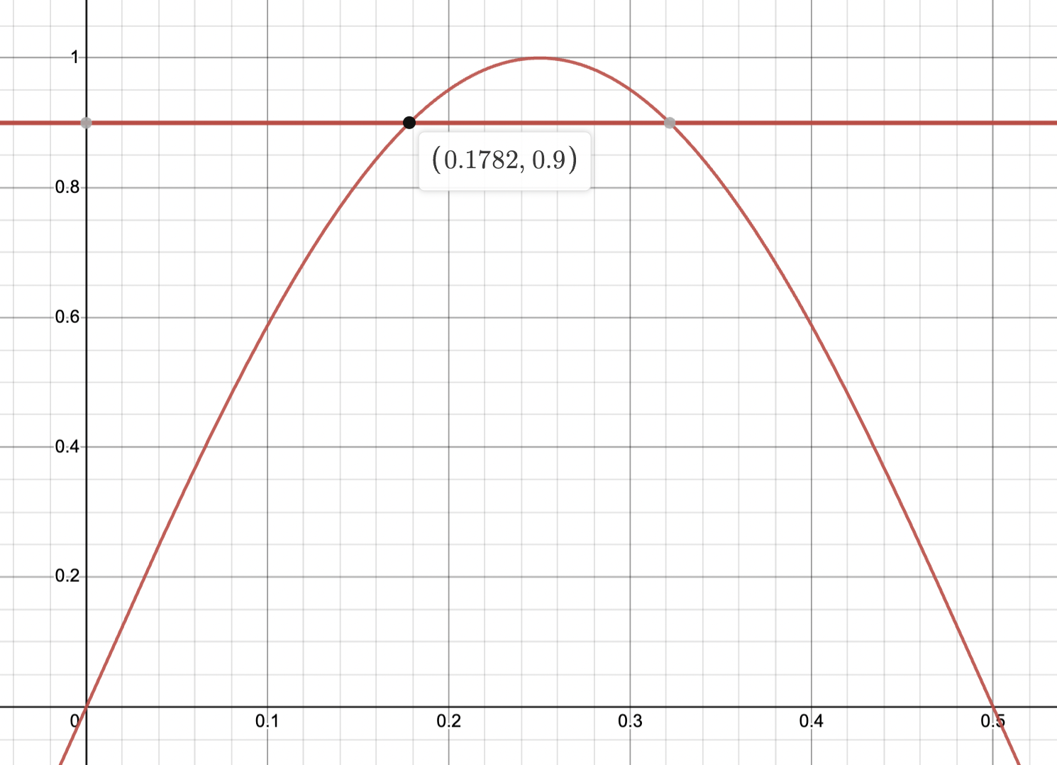 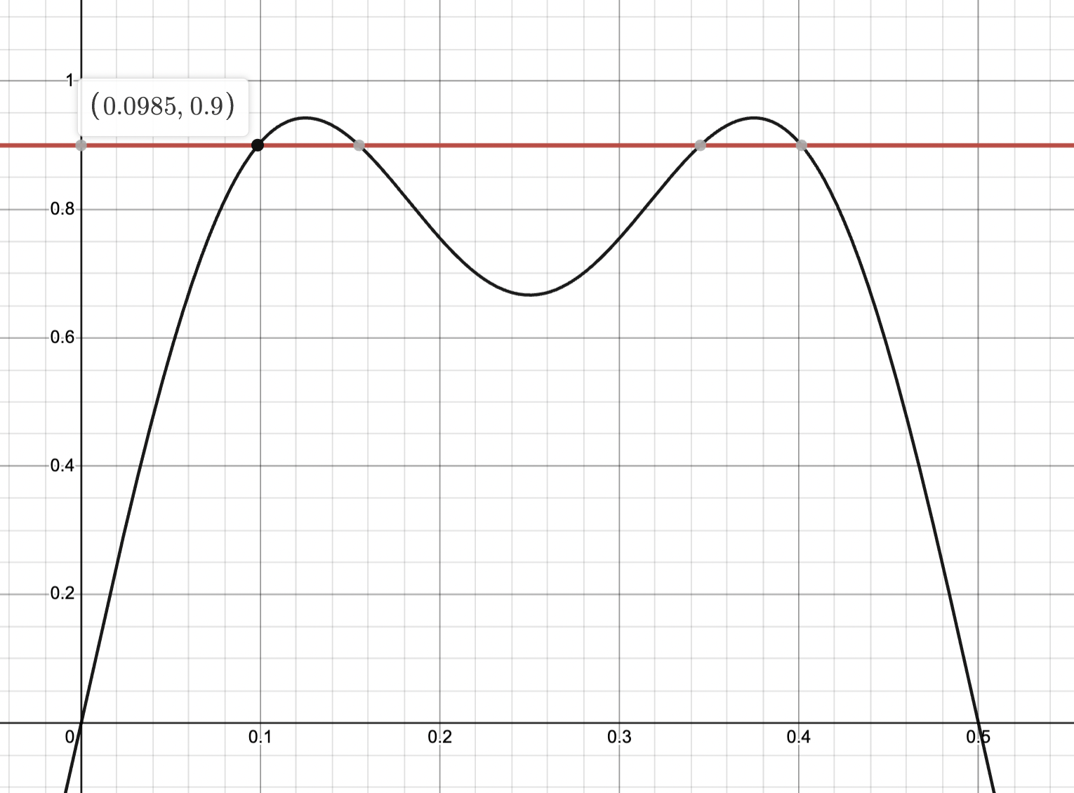 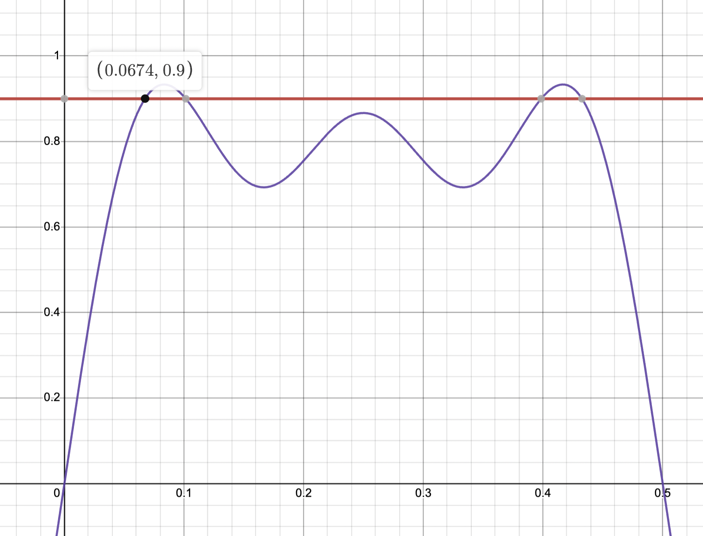

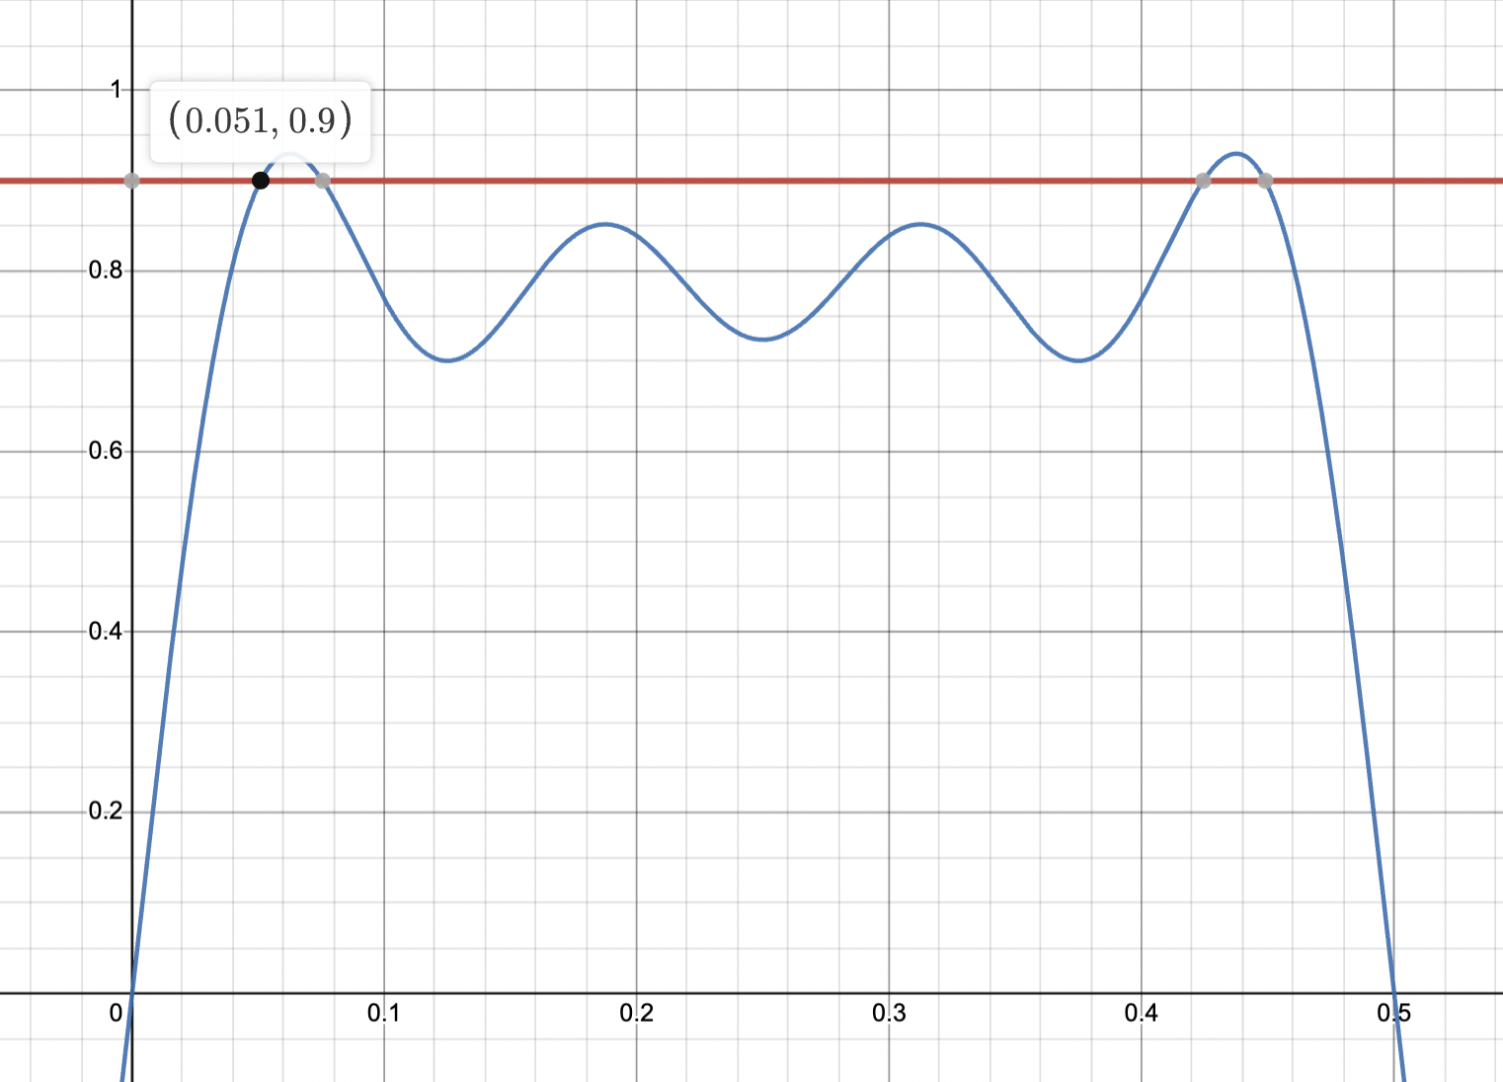 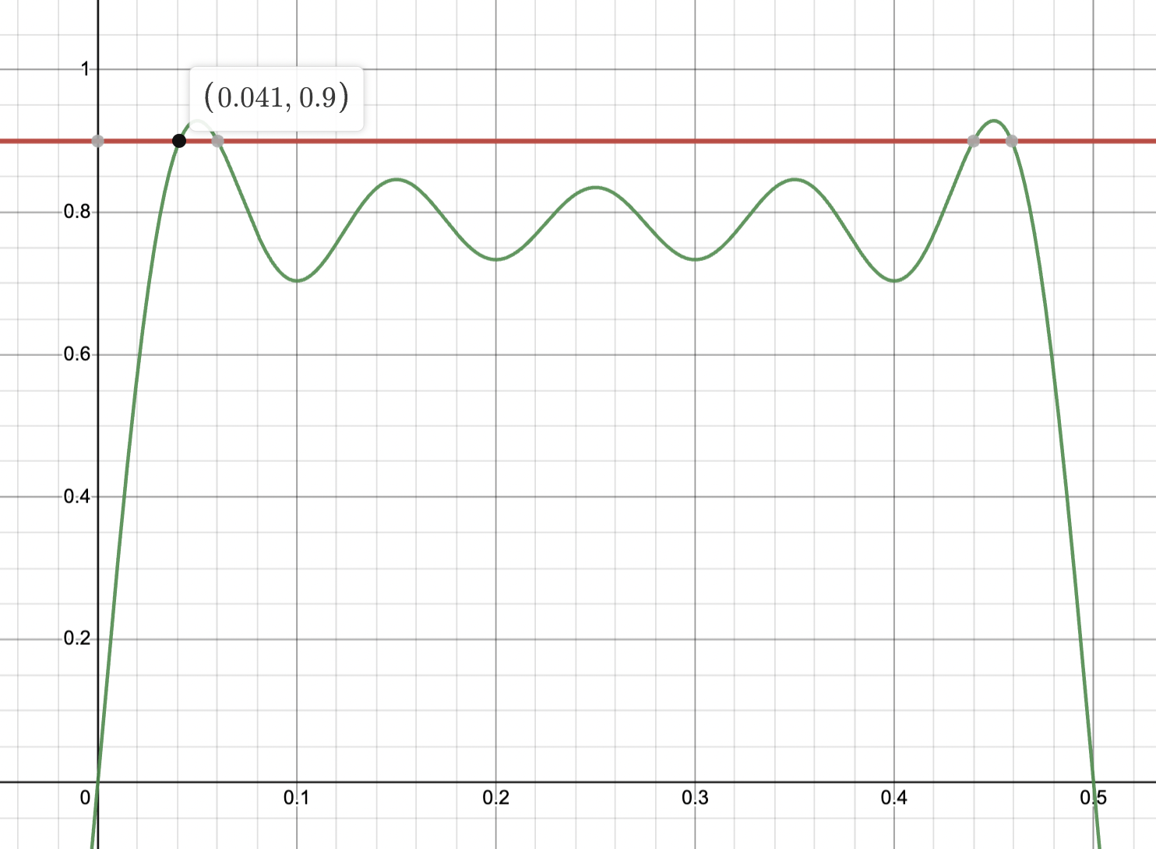

**Problem 2**

Part 2.1: Slow rate of every 2 usec

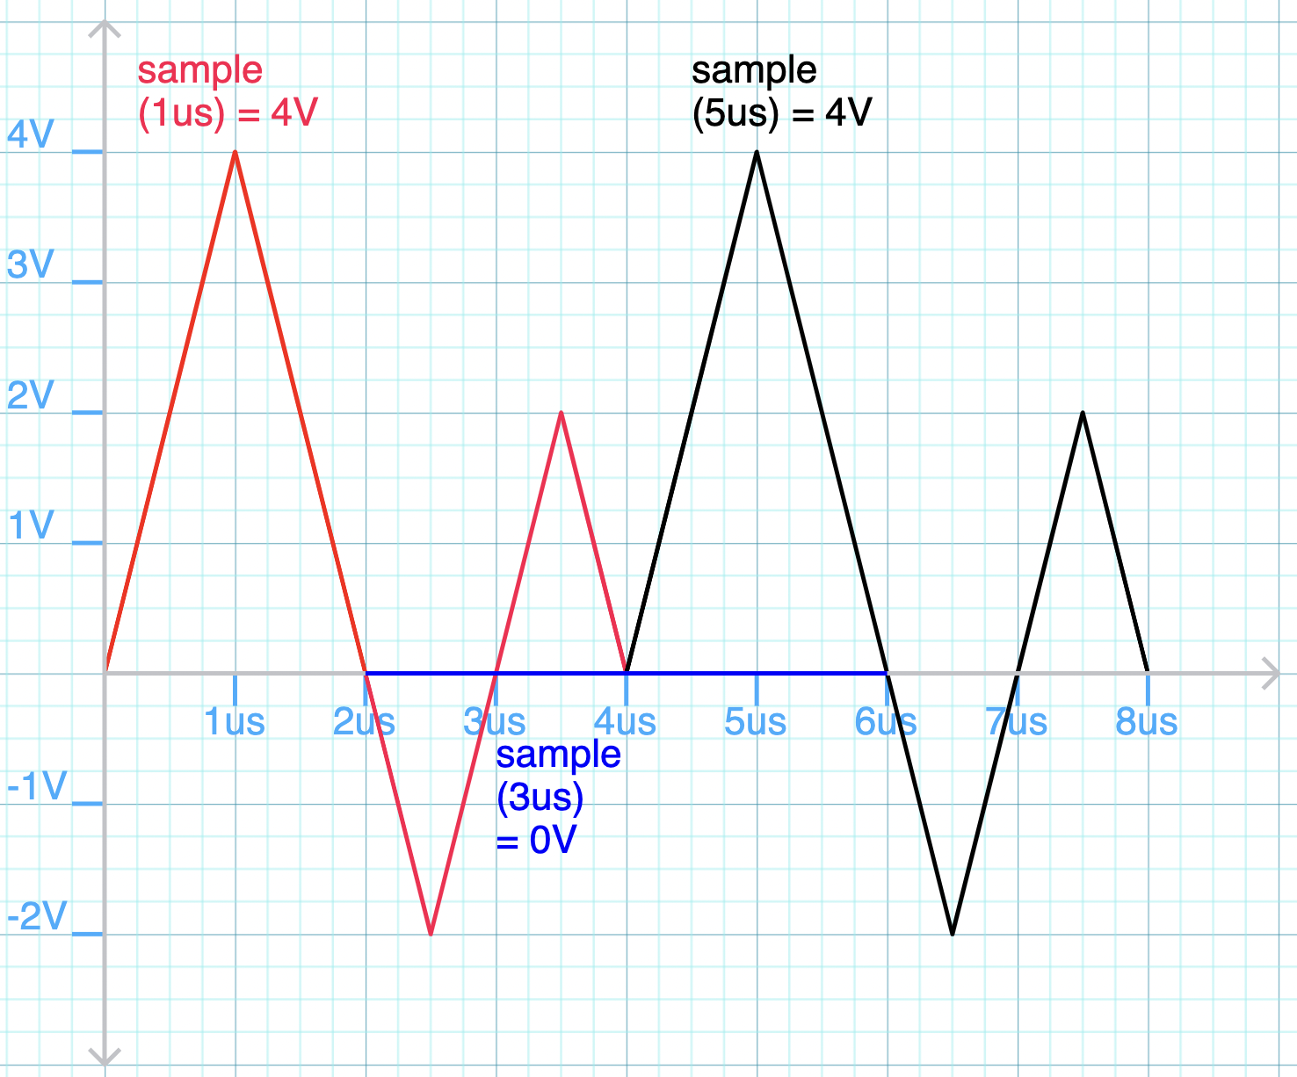

The receiver outputs 101.

Part 2.2: Fast rate of every 1usec.

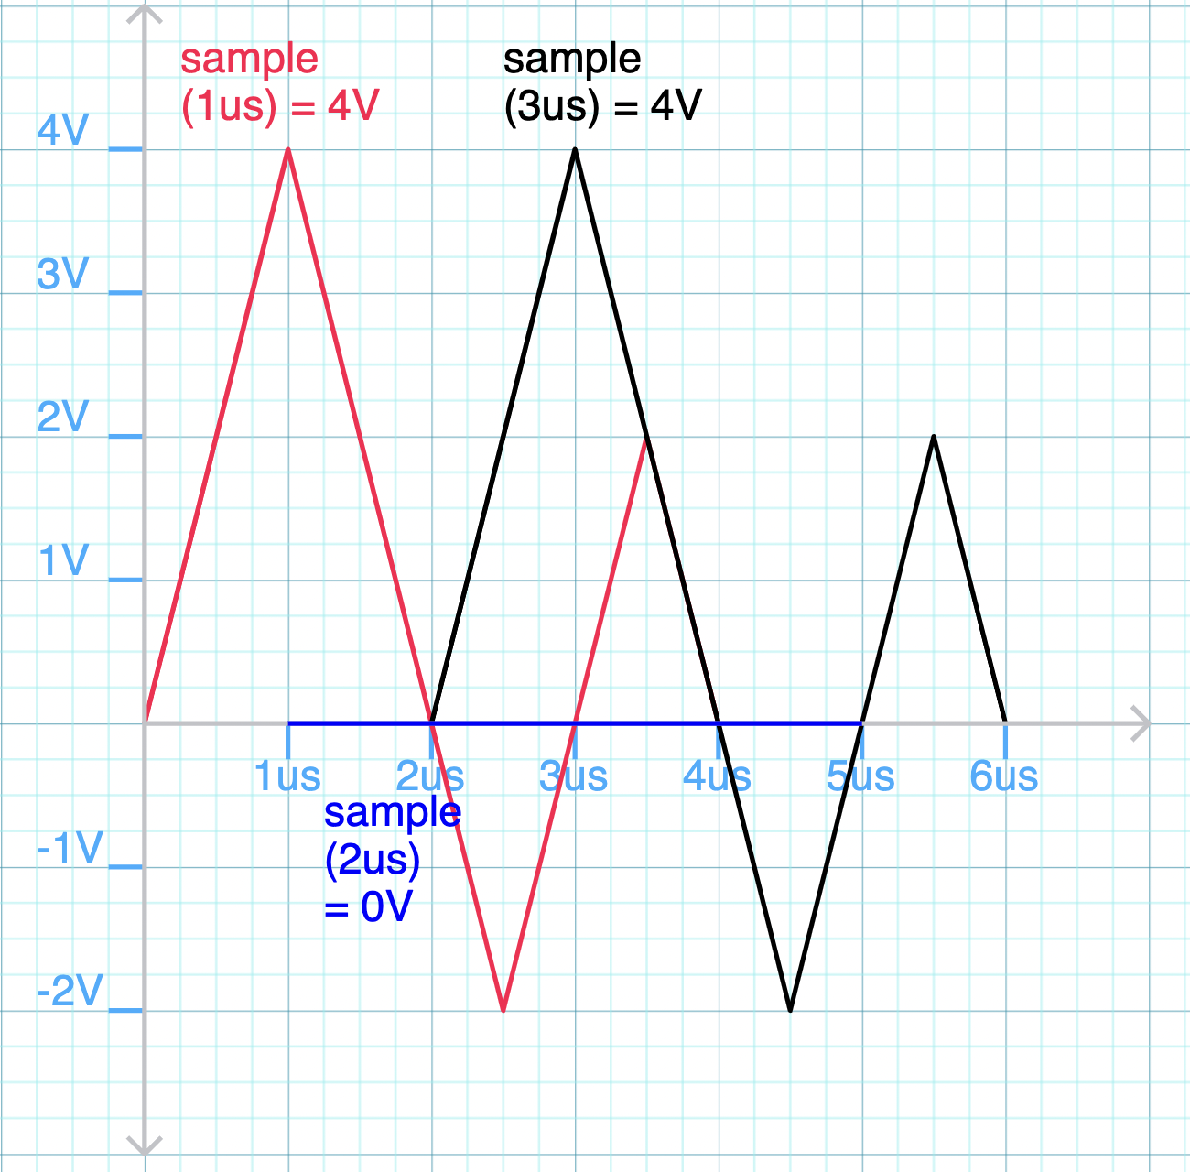

The receiver outputs 101.

Part 2.3: Super-sonic rate of every 0.5us.

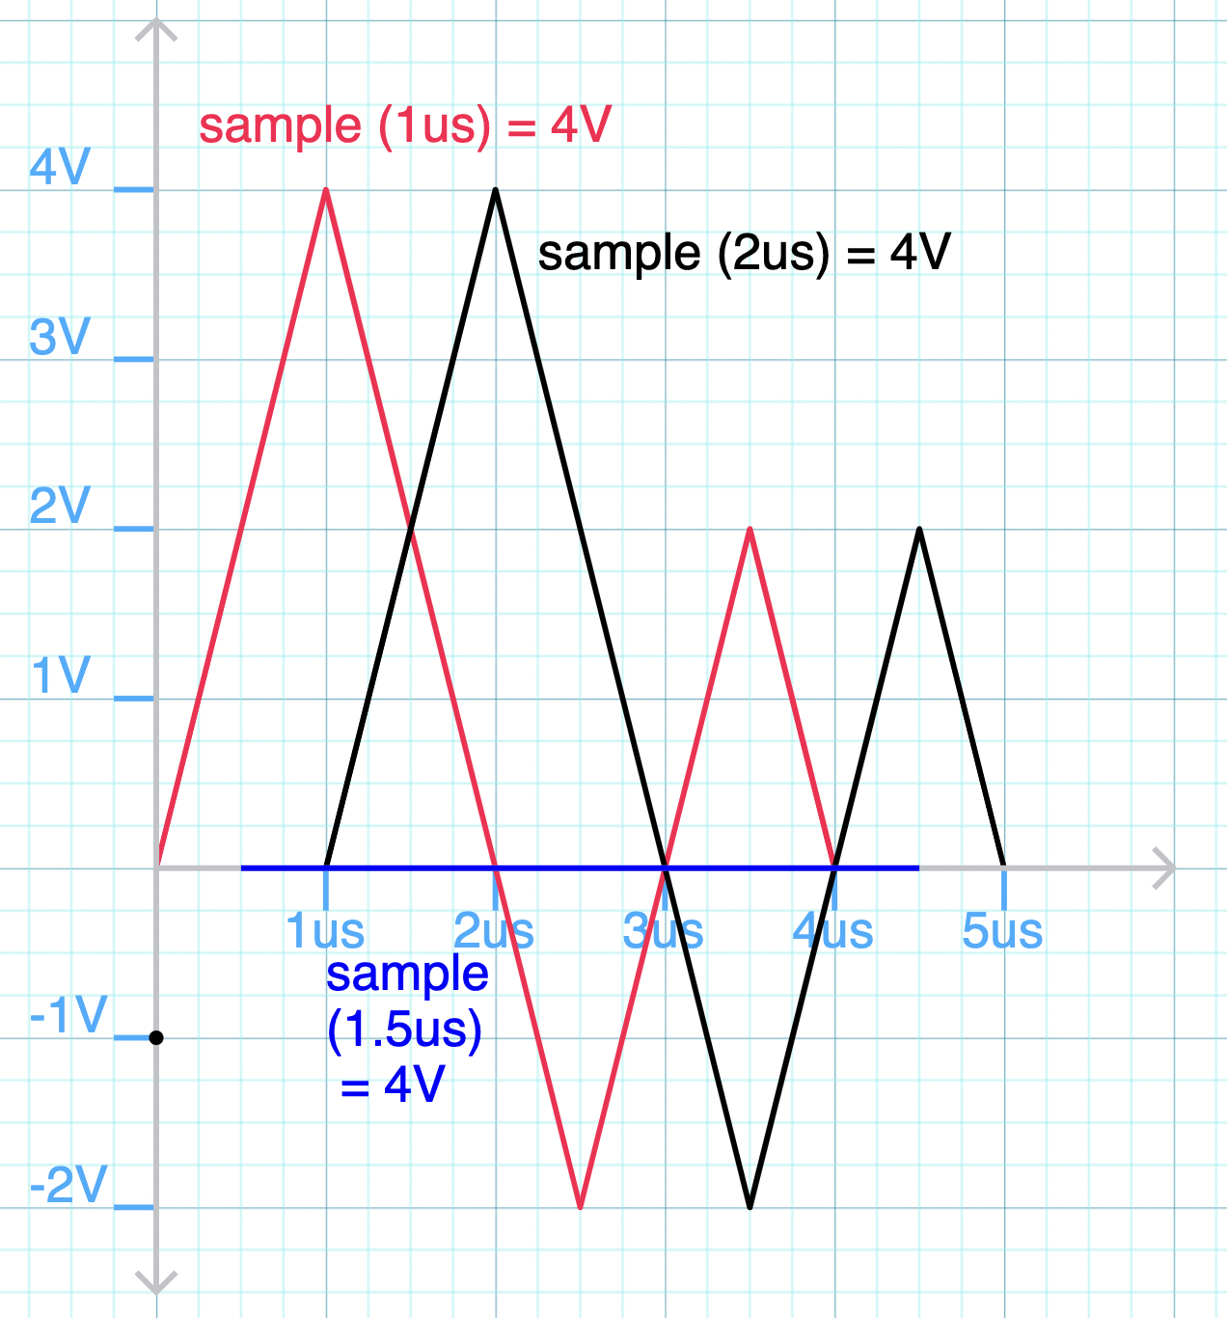

There is inter-symbol interference at the sample instance at 1.5us.

The receiver outputs 111.

**Problem 3**

Part 3.1 and 3.3:

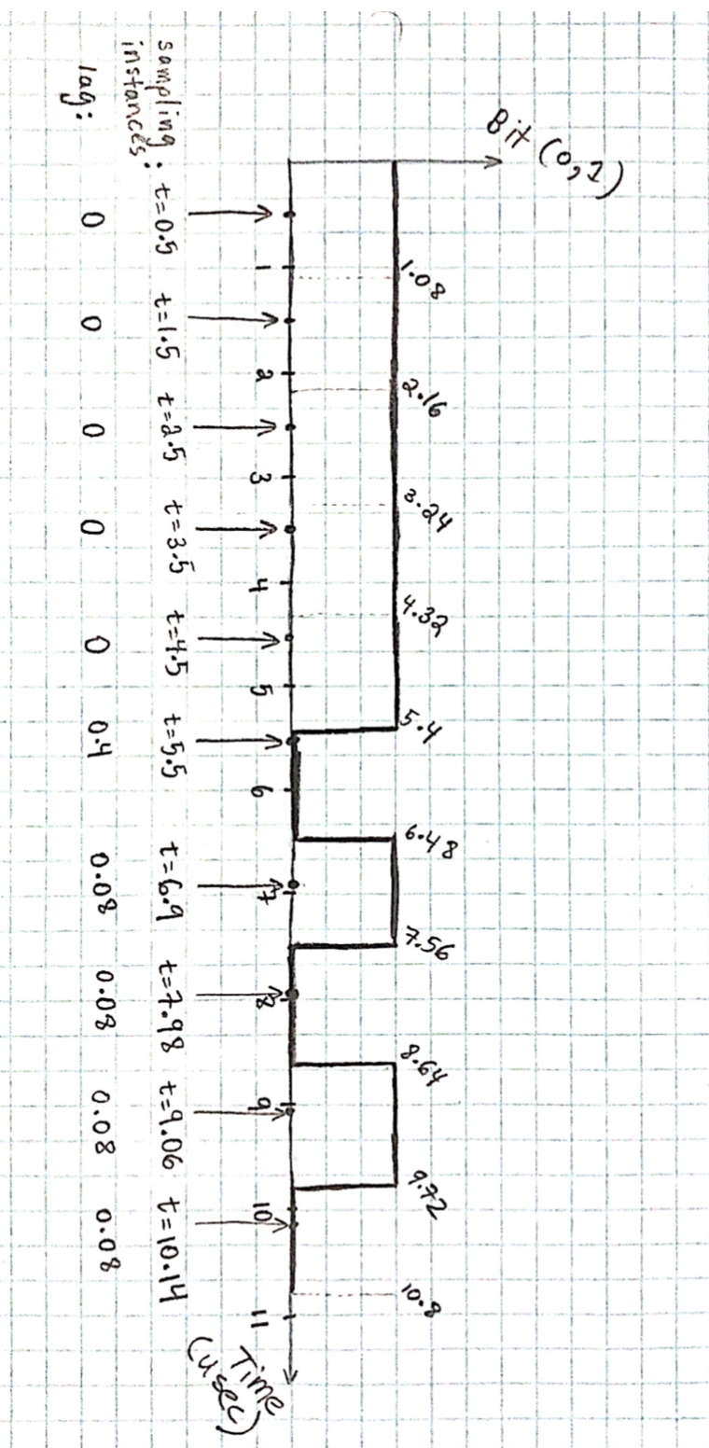

Part 3.2: The 10th sampling is at t = 9.5 usec. The 10th bit will start at t = 9.72 usec because of the slower sender clock. Therefore, the sample is off by 0.22 usec.

Part 3.4:

A noise spike of 1V at 0.3 usec results in a transition but will not be detected by the provided algorithm. So, the sample instances will remain the same as before. Observe that we wait for the first sample instance in the 2 lines above the loop, so until t = 0.5 usec is reached, the algorithm does not check for any transitions and does not adjust the lag value. I.e., a transition at time t < 0.5 usec will not be detected and the sample instances will be the same as before. I.e., the output will still be 1111101010.

Part 3.5:

If there is a sharp noise spike of -1V at time 2.7 usec, then a false transition will be detected at actual time A = 2.7 usec while waiting to reach sample instance at t = 3.5 usec. Thus, the detector will think that there was a transition at t = 2.7 usec while it is expecting that a transition should have happened at P = 3 usec. The lag value will be A – P = -0.3 usec and the next expected transition (the new value of P) will be 3.7 usec. This needlessly slows down the receiver clock and results in the wrong output (11111101010 – an extra 1 is read).

Spike at 2.7usec: No spikes:

